## Notes

1.1

Normative statements

Positive statements: Positive statement have the thing call cause and effect. For example, rasing taxing(cause) and growth of economic (effect)

1.2 Lecture 3: Applying supply and demand

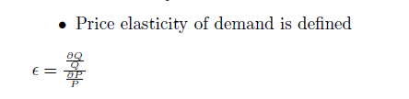

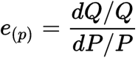

e_{(p)} = price elasticity

Q = quantity of the demanded good

P = price of the demanded good

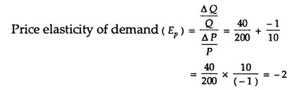

Explain what the elasticity of demand/supply imply about changes in equilibria.

## Assignments

### Problem set 1